

**Invention Disclosure Form**

**Section A: Applicant(s)/Inventor(s) Details**

1. **APPLICANT DETAILS**

| Name: SR University, Warangal | Mobile No. 9849426581 |
| --- | --- |
| Email: registrar@sru.edu.in | Nationality: Indian |

Address: Ananthasagar, Hasanparthy (PO), Warangal-506371

**2. INVENTOR DETAILS**

1. **First Inventor**

|  |  |
| --- | --- |
| Name: Kothakonda Chandhar | Mobile No. 8184857879 |
| Email: chandu19024@gmail.com | Nationality: Indian |
| Address: SR University, Ananthasagar, Warangal, Telangana, India | |
|  | |
|  | Sign_________________________ |
|  |  |

1. **Second Inventor**

| Name: Bethi Niyathi | Mobile No. 7780500656 |
| --- | --- |
| Email:bethiniyathii@gmail.com | | Nationality: Indian |

Address: SR University, Warangal, Telangana, India.

Sign_________________________

1. **Third Inventor**

| Name: Renikindi Amulya | Mobile No. 7013553018 |
| --- | --- |
| Email: reikindiamulya@gmail.com | Nationality: Indian |

Address SR University, Ananthasagar, Warangal, Telangana, India

Sign_________________________

1. **Fourth Inventor**

| Name: Dyagala Divya | Mobile No. 9492135863 |
| --- | --- |
| Email: divyaadyagala@gmail.com | Nationality: Indian |

Address: SR University, Ananthasagar, Warangal, Telangana, India

Sign_________________________

**e. Fifth Inventor**

| Name: Bongu Preethika | Mobile No. 9381065134 |
| --- | --- |
| Email: preethikabongu@gmail.com | Nationality: Indian |

Address: SR University, Ananthasagar, Warangal, Telangana, India

Sign_________________________

**Section B: Your Invention**

1. **­­­­­­­­­­­­­­­­­** **PARENT AND CHILD TRACKING SYSTEM FOR ENHANCED SAFETY AND SECURITY**
2. **­­­­PROBLEM STATEMENT:**

In today's fast-paced world, parents often face challenges in ensuring the safety and security of their children, especially in crowded or unfamiliar environments. The inability to monitor a child's whereabouts in real-time can lead to anxiety for parents and potential risks for children. There is a significant need for a tracking system that allows parents to keep an eye on their children’s location, ensuring they are safe and secure at all times. This system should utilize advanced geolocation technology to provide accurate, real-time tracking, constant connectivity, and user-friendly features. The implementation of such a device could greatly enhance parental peace of mind, empower children to explore their surroundings safely, and facilitate quicker responses in case of emergencies.

1. **EXISTING SOLUTIONS / PRIOR ART/RELATED APPLICATIONS & PATENTS:**

1. Development of GPS-enabled wearable devices specifically designed for child tracking.

2. Integration of mobile applications that provide real-time location sharing between parents and children.

3. Utilization of geofencing technology to create safe zones and alert parents when children leave these areas.

4. Implementation of Bluetooth and RFID technology for close-range tracking in crowded places.

5. Enhanced communication features that allow for direct contact between parents and children through the tracking device.

**D.DESCRIPTION OF PROPOSED INVENTION:**

The proposed invention aims to develop a smart tracking system designed for parents and children, integrating advanced geolocation and monitoring features to ensure child safety and enhance parental peace of mind. By leveraging modern technologies, this device will allow real-time tracking, health monitoring, and communication between parents and their children, especially in emergency scenarios.

This smart tracking device uses GPS/GNSS technology to provide precise, long-range location tracking, ensuring parents can keep track of their child's whereabouts at all times. In addition to location monitoring, the device incorporates health monitoring features like heart rate sensors, temperature sensors, and motion detection to detect falls or unusual activities, enhancing child safety.

The device is equipped with wireless communication technologies such as Bluetooth, Wi-Fi, and cellular service, enabling seamless data transmission to a centralized platform or smartphone application. Parents can access real-time location data, activity alerts, and health monitoring updates via a user-friendly mobile or web interface.A

**Key Features:**

**1. Location Tracking:**

* Real-time location updates using GPS or GNSS technology.
* Geofencing alerts to notify parents if a child leaves a designated safe zone.
* A history log of the child’s movements for review.

**2. Health and Activity Monitoring:**

* Built-in sensors (e.g., accelerometers, gyroscopes) to detect unusual movements or falls.
* Continuous heart rate and temperature monitoring for signs of distress or illness.

**3. Emergency Alerts:**

* An SOS button on the device that a child can press in case of danger, immediately alerting the parent or guardian.
* Automatic fall detection or panic mode activation based on abnormal health or movement patterns.

**4. Two-Way Communication:**

* A built-in speaker and microphone for direct communication between the child and the parent.
* Emergency instructions or reassurance can be provided to the child in real-time.

**5. Data Security and Privacy:**

* Robust encryption protocols to ensure all transmitted data remains secure and adheres to privacy standards.
* Cloud-based storage with access control for parents to monitor activity while protecting sensitive data.

**6. Parental Customization:**

* Tailored notifications for geofence breaches, inactivity, or unusual health patterns.
* Adjustable settings for individual child needs or family requirements.

**Workflow of Parent and Child Tracking System:**

**1. Data Collection:**

Gather real-time data from sensors, including location, heart rate, body temperature, and motion detectors.

**2. Health and Movement Monitoring:**

Continuously monitor physiological data and motion patterns to detect unusual activities, such as falls or signs of distress.

**3. Real-Time Location Updates:**

Provide continuous location tracking, with periodic updates sent to the parent's application.

**4. Data Analysis and Alert System:**

Analyze data in real-time to identify abnormalities (e.g., rapid heart rate, geofence breaches, or falls). Trigger alerts to notify parents immediately.

**5. Parent Communication Interface:**

Provide parents with access to the child’s data through a secure mobile or web application. This includes real-time location tracking, historical activity logs, and health status.

**6. Emergency Response and Communication:**

* Enable two-way communication for emergencies.
* Dispatch emergency notifications to parents and caregivers if danger is detected.

**7. Software Maintenance and Updates:**

Regular updates ensure the system's reliability, functionality, and data security while addressing user feedback for improved performance.

This smart system, designed for convenience, reliability, and security, ensures comprehensive child safety while fostering stronger connections between parents and children in both day-to-day and emergency scenarios.

**ARCHITECTURE DIAGRAM:**

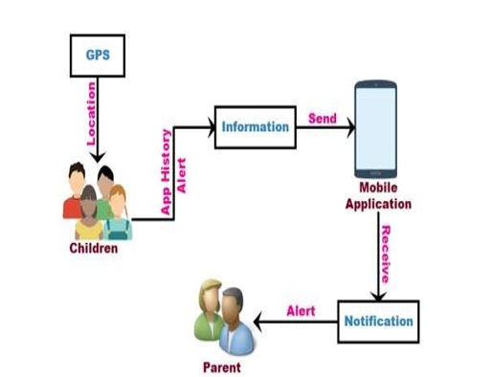

**E. NOVELTY:**

**1. Customizable Alerting System:**

The device is specifically designed to enhance safety for children. It alerts parents about unusual events such as geofence breaches, falls, or inactivity. The system can be tailored to provide customized notifications based on the child’s age, routine, and specific needs. This personalized approach helps parents respond quickly to potential emergencies and ensures the child’s well-being.

**2. Integration of Long-Distance Geolocation Capabilities:**

By incorporating advanced GPS/GNSS technology, this tracking device offers precise and reliable long-range location tracking. Parents can monitor their child’s real-time location even when they are far away. This feature is particularly helpful for keeping children safe during outdoor activities, school commutes, or crowded events, allowing for prompt action if the child ventures into unsafe areas.

**3. Wireless Connectivity and Remote Monitoring Platform:**

The device uses modern wireless communication technologies like Bluetooth, Wi-Fi, and cellular networks to seamlessly connect with a remote monitoring platform. This platform enables parents to access real-time data, receive instant alerts, and view historical location and activity logs. The connectivity ensures that parents remain informed, no matter where they are, and can make timely decisions to ensure their child’s safety.

**4. User-Friendly Interface and Accessibility:**

Designed with simplicity and usability in mind, the device features an intuitive interface suitable for both children and parents. It includes clear notifications, easy-to-use buttons, and an engaging display. The companion mobile application or web interface is straightforward, with easy navigation, visual cues, and customizable settings. This ensures that parents and children alike can interact with the device effectively, improving their overall experience.

This novel system combines advanced technology, safety-focused design, and user-friendly features to create a reliable solution for ensuring child safety and supporting parents in real-time decision-making.

**F. WORKING OF PARENT AND CHILD TRACKING SYSTEM:**

After the device is delivered, both the child and their parents or guardians should complete the registration process. Each device is uniquely linked to one child, but multiple parents or guardians can register to receive notifications and access real-time information about the child’s safety and location.

**1. Location Tracking Using GPS:**

A GPS following unit is a route gadget ordinarily conveyed by a moving vehicle or individual that utilizes the Global Positioning System (GPS) to follow the gadget's developments and decide its area. The recorded area information can either be put away inside the following unit.

**Home Page:**

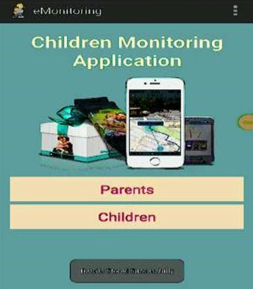

**User Information:**

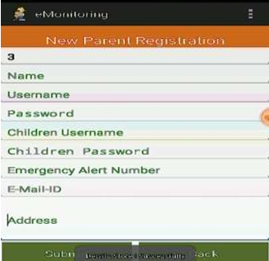

**2**.**Cellular Identification:** This application secure child will be very helpful to such worried parents and assures them the safety of the children. In this module, application which will take care of your child information gathered while the child is travelling to wherever GPS reading is used for tracking.

**User Login:**

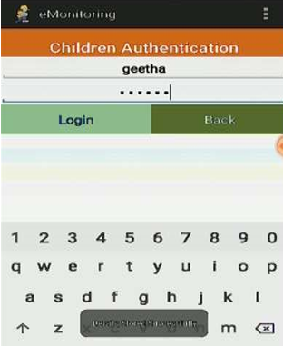

**3.Gathering Browsing History:** A Browsing History allows you to watch the browsing history of all user profiles in a running mobile, as well as to get the browsing history. In this module, all the browsing history of the child will be gathered.

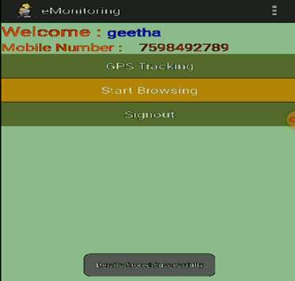

**4. Send Notification to Parents:** In this module, child information gathered to send a message to all connected parents. Then, the parents identify to child location details

**Notification:**

